

**Adding and Viewing the EPAF Submission Calendar**

EPAF and eGA submission dates will no longer be sent out in a monthly email; they are now available through a Google Calendar. To download the calendar:

1. 1) Go to <https://hr.uncc.edu/recruitment-and-hiring/temporary> ***or***
2. <https://hr.uncc.edu/recruitment-and-hiring/resources-hiring-student-employees>
3. Click on EPAF Submission Calendar. This will open your Google calendar and you should see this pop-up message:

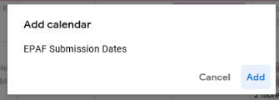

1. The first time it is accessed, it will prompt the user to add it as an additional calendar. Click ADD to add it your list of Available Calendars.
2. Once added, the calendar will be accessible in the list at the bottom left side of Google Calendar. Click the checkbox next to it in order to display the calendar.



Please note: This calendar is called EPAF Submission Dates, but it serves a dual purpose. It will put EPAF and eGA submission dates on your calendar.

